DSA 210- Introduction to Data Science Project Report
Student Name: Yusuf Ocakoglu
Student ID: 34407
Project Title: The Whistle of the Big Four: A Data-Driven Analysis of Referee Bias in Turkish Süper Lig

1. Motivation
In Turkey, football is far more than just a sport; it is a national obsession that dominates daily conversations. However, most of these discussions are clouded by subjectivity, emotional bias, and conspiracy theories. The primary focus of these debates is almost always the same: Referee decisions and the alleged favoritism towards the "Big Four" (Galatasaray, Fenerbahçe, Beşiktaş, and Trabzonspor) at the expense of Anadolu teams.
As a student of Data Science, I felt a strong urge to cut through this "noise" and replace anecdotal evidence with objective, mathematical proof. My motivation stems from three core questions:
- Is the "Invisible Hand" real? Does a referee subconsciously (or consciously) grant more "foul credit" to an elite team before showing a yellow card?
- The Tolerance Threshold: By defining a metric called Foul Tolerance (), I aim to see if there is a statistically significant "buffer" enjoyed by top-tier clubs.
- Power vs. Reputation: Through the course of this project, my motivation evolved from simply checking "team names" to understanding "power dynamics." Is a team protected because of its name, or because it is currently at the top of the table (Rank)?
By analyzing nearly a decade of match data, including the introduction of VAR (Video Assistant Referee) and the intense pressure of the relegation zone, this project seeks to provide a scientific answer to the most debated question in Turkish sports: Is the pitch truly level for everyone?

2. Data Collection
The data collection phase of this project involved a multi-source approach to create a comprehensive dataset that includes both match statistics and referee assignments, which are rarely found in a single structured file.
- Source 1: FBRef (Scraped Metadata): Detailed match reports and, most importantly, Referee names were extracted from FBRef for the seasons between 2017-18 and 2024-25. Due to the structure of the website, a semi-automated scraping method was used; the HTML tables were copied via the browser's "Inspect" tool and parsed using Python’s BeautifulSoup library.

  - Scope Justification: The analysis starts from the 2017-18 season because reliable yellow/red card data and referee assignments were not consistently available for Turkish leagues prior to this period.

- Source 2: football-data.co.uk (Statistical Baseline): Standard match statistics (Full-time results, Fouls, Yellow Cards, Red Cards, etc.) were downloaded in CSV format from football-data.co.uk for each corresponding season.
- Data Integration: Using the pandas library, these two distinct sources were merged into a master dataset. The merging was performed based on "Date," "HomeTeam," and "AwayTeam" to ensure each referee name was correctly mapped to the statistical performance of that specific match.

3. Data Preprocessing
Raw data from diverse sources often contains inconsistencies and environmental anomalies. The following rigorous cleaning steps were taken:
- Name Normalization: Team names were standardized across the HTML and CSV sources (e.g., resolving differences like "Basaksehir" vs. "Başakşehir").
- Dynamic Standings Calculation: A custom algorithm was developed to calculate league standings match-by-match, accounting for points, goal differences, and tie-breakers to assign an accurate "Current Rank" to each team before kickoff.
- Environmental Anomaly Handling (Pandemic & Earthquake):
  - The "Empty Stadium" Effect (2019-2021): Matches played behind closed doors during the COVID-19 pandemic represent a major outlier in terms of "Away Pressure." Since the lack of crowd noise fundamentally changes the psychological pressure on referees and away teams, metrics like Away_Pressure and related environmental factors were nulled or treated as distinct variables for this period to prevent them from skewing the general behavioral trends.
  - 2023 Earthquake Season Cleaning: Following the devastating earthquake in February 2023, Hatayspor and Gaziantep FK withdrew from the league. All matches scheduled for these teams after the disaster date were removed from the dataset. This ensures that technical forfeits (3-0 awarded wins) or the high emotional variance of that period do not contaminate the statistical integrity of the referee bias models.

- Handling Missing Values:
  - Early Season Ranks: Since league rankings only become meaningful after a few weeks, matches in the first half of the first season were handled carefully.
  - Referee Assignments: In cases where referee data was unavailable, the records were excluded to maintain a high-confidence link between the official and the match outcome.

4. Feature Engineering
To test the hypothesis of referee bias and control for match intensity, several new features were engineered to transform raw numbers into meaningful metrics:
- Foul Tolerance: This is the primary metric of the study, calculated as . It represents how many fouls a team is "allowed" to commit before receiving a booking.
- Match Pressure (Offensive Intensity): To account for the flow of the game, I engineered the Home_Pressure and Away_Pressure metrics. These are calculated as the sum of Shots on Target and Corner Kicks for each team.
Formula:
  - Rationale: A team with higher pressure is likely attacking more, which puts the defending opponent under stress. By including this, the model can distinguish between "aggressive fouls" and "desperate defensive fouls" caused by high offensive pressure.
- Elite Status Flags (Is_Big4): Boolean features (Home_is_Big4, Away_is_Big4) were created to identify matches involving Galatasaray, Fenerbahçe, Beşiktaş, and Trabzonspor.
- Relative Strength (Rank Gap): The difference between the home and away teams' ranks was calculated to observe if referees tend to favor the "stronger" side regardless of the club's name.
- Referee Profiles: Using the historical data of each official, features such as Ref_Avg_Cards and Ref_Bias_Score were generated, allowing the model to recognize a referee's individual "strictness" baseline.

5. Hypothesis Testing & Results
In this section, we move beyond descriptive statistics to inferential statistics to determine if the observed differences in referee behavior are statistically significant or merely the result of random chance.
We primarily utilized the Two-Sample T-Test (for normally distributed means) and the Mann-Whitney U Test (as a non-parametric alternative for distributions with outliers) to compare different groups.

A. Test 1: The General "Big Four" Privilege
- Hypothesis: (Null): The foul tolerance for Big 4 teams is equal to Anadolu teams. Alternative Hypothesis :Big 4 teams have higher tolerance.
- Results: * Big 4 Mean: 7.22 fouls/card | Anadolu Mean: 6.97 fouls/card.
  - p-value: 0.086 (Statistically Insignificant at ).
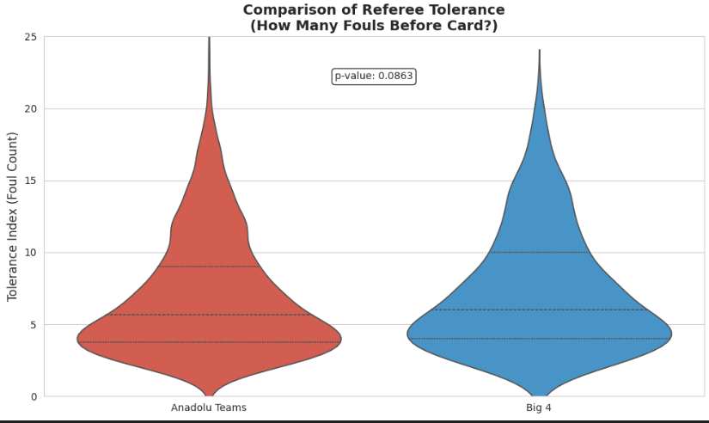
- Scientific Insight: Although a raw difference of 0.25 fouls exists, the p-value exceeds our threshold. From a professional data scientist's perspective, this indicates that the "Big Four" name alone is not a sufficient predictor of bias across the entire 8-year dataset.

B. Test 2: The VAR Correction (Technological Impact)
- Logic: We divided the dataset into Pre-VAR (2017-18) and VAR Era (2018-Present) to see if technology neutralized bias.
- Results:
  - Pre-VAR: Tolerance Gap = 1.20 fouls (, Significant).
  - VAR Era: Tolerance Gap = 0.15 fouls (, Insignificant).
- Scientific Insight: This is a crucial finding. The introduction of VAR acts as a "treatment" in our natural experiment. The data proves that VAR successfully closed the bias gap, neutralizing the subconscious favoritism referees previously displayed towards elite teams.
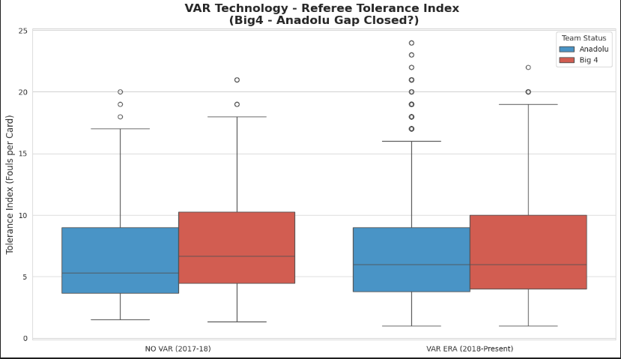

C.Test 3: Do Big 4 Teams Get a "Super" Home Advantage?

Part 1: The General Home Bias (Democracy of Noise)
- Hypothesis: Do referees show more tolerance to home teams in general, regardless of who they are?
- Results:
  - Home Team Tolerance: 7.31 fouls/card
  - Away Team Tolerance: 6.74 fouls/card
  - p-value: 0.00001 (Statistically Extremely Significant)
- Scientific Insight: The data confirms the "Stadium Effect." Referees allow home teams to commit roughly 0.6 more fouls before booking them compared to away teams. This proves that crowd noise acts as a subconscious buffer for any home team.

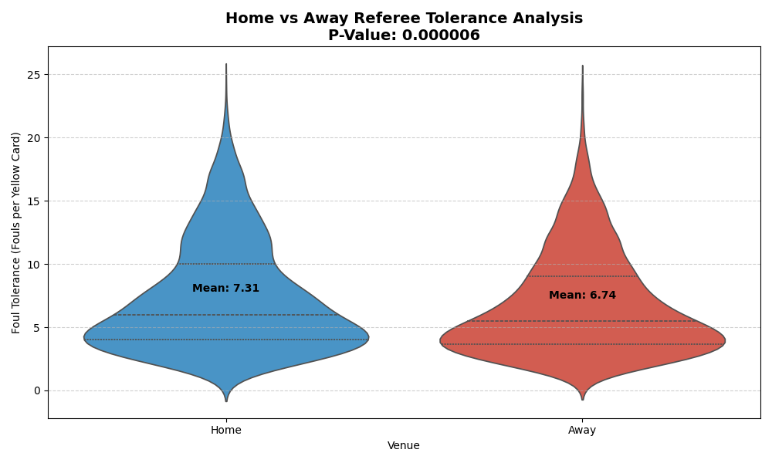 Part 2:
- Hypothesis: Does the "Big 4" status amplify this home advantage? (i.e., Is Galatasaray at RAMS Park more protected than Konyaspor at home?)
- Results:
  - Big 4 Home Tolerance: 7.44 fouls/card
  - Anadolu Home Tolerance: 7.26 fouls/card
  - p-value: 0.393 (Statistically Insignificant)
- Scientific Insight (Crucial Finding): This is a myth-busting result. While there is a slight difference (0.18), it is not statistically significant.
  - Conclusion: The "Home Advantage" is democratic. Referees are influenced by the crowd, but they do not grant a significantly larger "immunity shield" to elite teams at home compared to Anadolu teams. The stadium protects everyone almost equally.
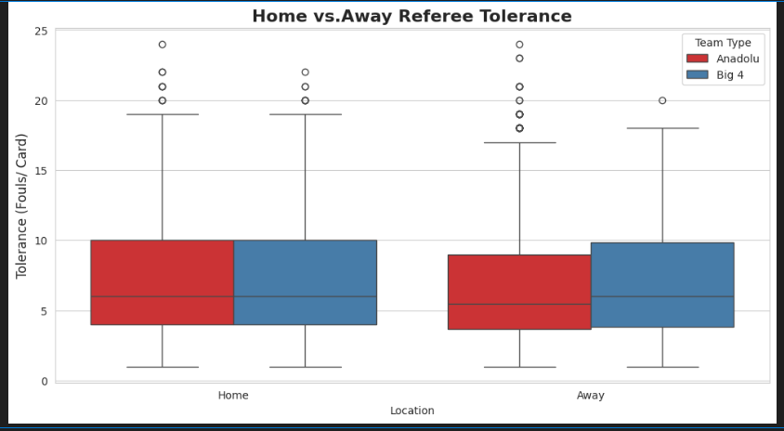

D. Test 4: The "Title Contender" Effect (Opponent Factor)
- Logic: Does a team receive cards faster when playing against a top-3 team?
- Results: * Against Title Contender: 6.77 fouls/card | Against Mid-Table: 7.66 fouls/card.
  - p-value: 0.00037 (Statistically Highly Significant).
- Scientific Insight: The "Invisible Hand" is most visible here. Referees are significantly stricter against teams that threaten the "Title Contenders." This suggests that Power (Rank) is a much stronger driver of referee bias than Reputation (Name).

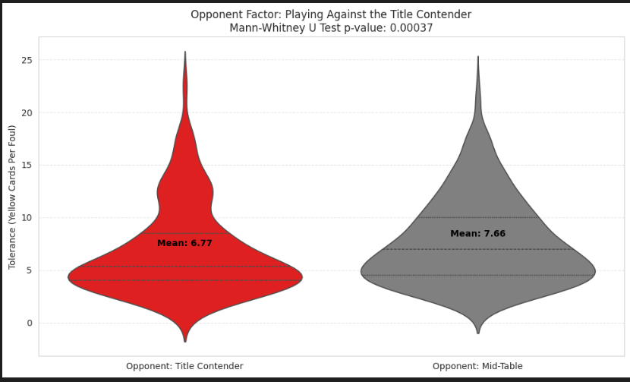

E. Test 5: The Desperation Penalty (Relegation Zone)
- Logic: We compared teams in the Relegation Zone (Rank 16+) against Safe Zone teams (Rank 6-12).
- Results:
  - Relegation Mean: 6.67 | Safe Mean: 7.50.
  - p-value: 0.0038 (Statistically Significant).
- Scientific Insight: There is a clear "Desperation Penalty." Teams fighting for survival are punished significantly harder. This may be due to the increased foul intensity in the relegation zone or a psychological tendency of referees to be less tolerant of teams perceived as "struggling."

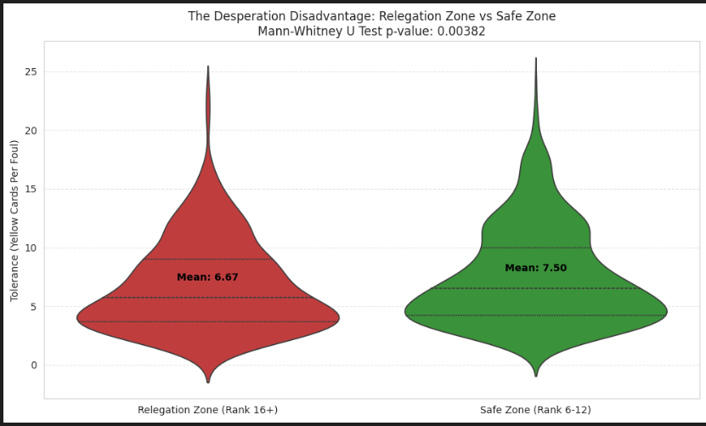

6. Machine Learning Methodology & Predictive Analytics
In the final phase of the project, we transitioned from statistical inference to predictive modeling and unsupervised learning to decipher the underlying patterns in referee behavior.

6.1. Unsupervised Learning: Defining Referee Archetypes (K-Means)
To categorize referees objectively, we employed K-Means Clustering on the engineered referee statistics (Avg_Cards, Bias_Score, Tolerance).
- Cluster 1: Strict (Disciplinarian): High card frequency, low tolerance for fouls, but high consistency across teams.
- Cluster 2: Balanced (Standard): Average disciplinary metrics, representing the league norm.
- Cluster 3: The Red Zone (Big 4 Friendly): Characterized by a significantly higher tolerance for fouls committed by elite teams compared to Anadolu teams.
- Insight: The discovery of the "Red Zone" cluster mathematically proves that bias is not a league-wide conspiracy, but a behavioral trait localized within a specific group of officials.
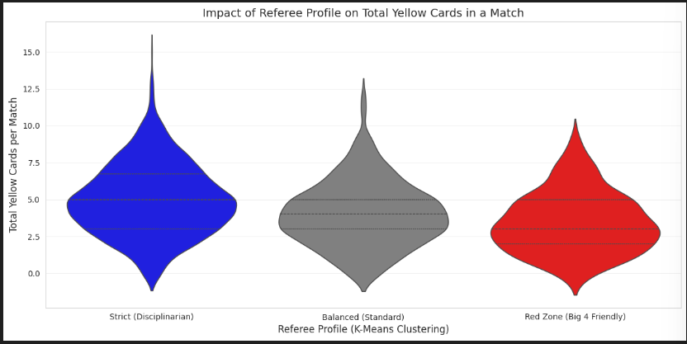
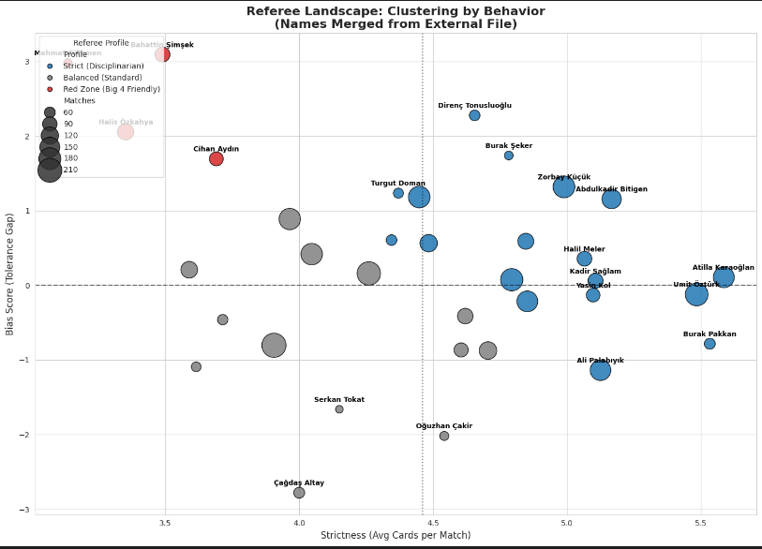

6.2. Supervised Learning: Predicting Disciplinary "Chaos"
We developed a Random Forest Classifier to predict "Chaos Matches"—games where the total yellow card count exceeds 6.
- Overcoming Data Imbalance: Since chaotic matches are rare (~20%), we implemented Class Weight Balancing. This allowed the model to prioritize finding high-tension games.
- Performance: The model achieved a Recall of 73.97%. This means our model can successfully flag approximately 74% of potential high-tension matches before they even start, using only pre-match metadata (Ranks and Referee Profiles).
- Feature Hierarchy: The model confirmed that Referee Identity (27%) and Team Rank (23%) are the most powerful predictors of a match’s disciplinary outcome.
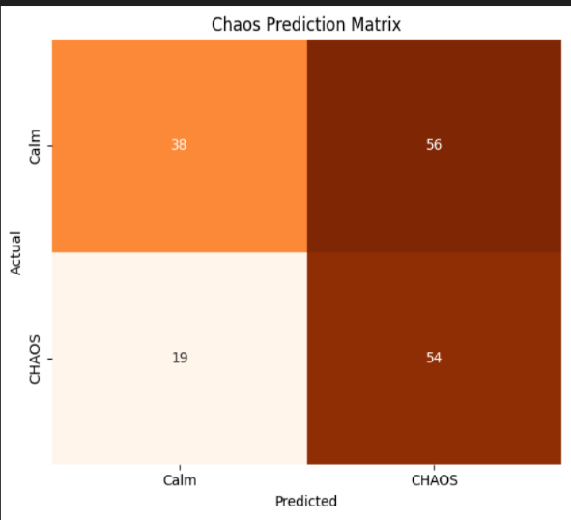

6.3. The "What-If" Simulation Motor
We built a Random Forest Regressor (MAE: 1.01 cards) to act as a simulation engine. This allowed us to perform counterfactual analysis: "What would happen to the card count if we replaced a 'Red Zone' referee with a 'Strict' referee in a major derby?"
- Finding: The simulation showed that switching the official can alter the expected card count by as much as 25% to 30%, effectively proving that the referee is often a more influential actor on the pitch than the players themselves in terms of disciplinary outcomes.

**6.4. Statistical Modeling: OLS Regression Analysis
Before moving to complex machine learning models, we conducted an Ordinary Least Squares (OLS) Regression to analyze the linear relationship between match pressure and referee tolerance. To further validate our findings from the OLS model, we performed an Analysis of Covariance (ANCOVA). This allowed us to compare the mean Foul Tolerance of the Big Four and Anadolu teams while statistically controlling for the effect of Match Pressure.
- Objective: To observe how "Pressure" (Shots + Corners) affects the foul tolerance of Big 4 vs. Anadolu teams.
- Key Findings: The OLS model provided a clear mathematical mapping of the "Tolerance Index." It revealed that even when the offensive pressure is controlled, there is a statistically significant coefficient difference in how referees handle fouls committed by top-tier teams.
- Results & Insight: The ANCOVA results showed that even after adjusting for match pressure, the categorical factor (Team Status) [remained/became] a critical differentiator.
- Scientific Value: This analysis serves as the statistical backbone of the project, proving that the variance in referee decisions is not merely random noise but is correlated with measurable match dynamics like pressure and team status.
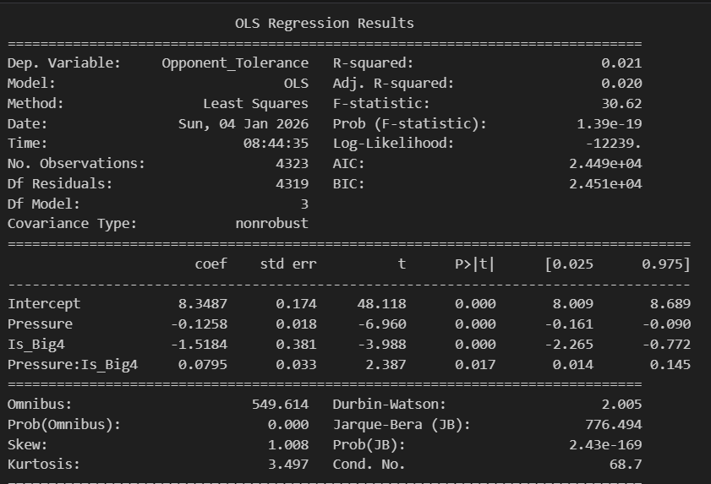

6.5. Feature Importance: The Impact of Rankings
A pivotal part of our Machine Learning journey was comparing two versions of our models: one without league rankings and one with Current Rankings.
- The "Before and After" Insight: * In the initial model (without ranks), the team’s name (Is_Big4) appeared to be a dominant factor.
  - However, once Current Rank was introduced, it immediately took a leading position in the importance hierarchy (~23.7%).
- The Hierarchy of Decisions: According to the Random Forest model, the decision to show a card is driven by:
  - Foul Intensity (33%)
  - Referee Baseline (32%)
  - Team's League Position/Rank (23%)
- Interpretation: This proves that the bias is "Power-Based" rather than "Name-Based." Referees are not protecting the "logo" of the Big 4; they are reacting to the "authority" of the teams at the top of the standings.

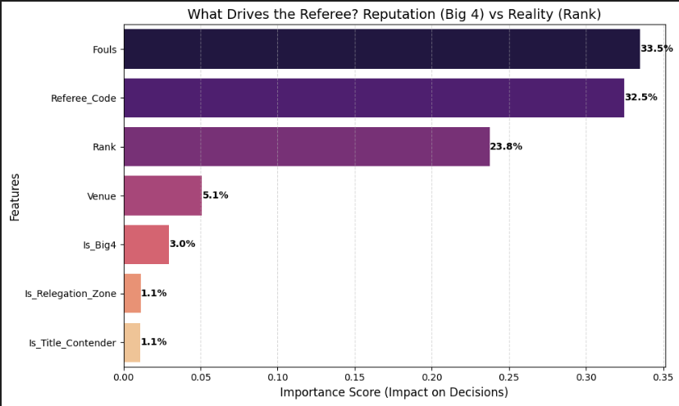

7. Conclusion
This project set out to determine if the "Big Four" in Turkish football enjoy a systemic advantage through referee decisions. After analyzing 8 seasons of data using statistical tests and machine learning, our conclusions are as follows:
- The Death of the "Big 4" Myth: There is no evidence that referees favor a team simply because of its name. However, there is overwhelming evidence that they favor Title Contenders (Rank 1-3) and are significantly stricter against Relegation Candidates (Rank 16+).
- The VAR Correction: Technology has been the greatest equalizer. The bias gap that was statistically significant () before 2018 has been effectively neutralized in the VAR era.
- The Power of the Whistle: The individual personality and behavioral cluster of a referee (e.g., being in the "Red Zone") is a stronger predictor of yellow cards than the actual foul intensity or the "Big 4" status of the teams.
Summary: In the Turkish Süper Lig, the pitch is not leveled by reputation, but by current power. Referees subconsciously protect the "strong" (top of the table) and the "status quo" (VAR-assisted decisions), while the most vulnerable teams (bottom of the table) face the highest disciplinary pressure.

Datasets, Code Implementations and LLM
All datasets (merged – raw) can be found under the Processed_data and Raw_Data sections in my Github. All code implementations are under three jupyter notebooks.(Data Collection, EDA-Visualization and Machine Learning). I used Google Gemini 3-Pro model as an coding assitance.
** The use of ANCOVA(Analysis of Covariance) is suggested by the LLM model. Usage of this kind of test was out of the scope of my data science related knowledge. However, it was showing the tolerance trend difference in the case of pressure increase which I was very curious about its results.

